1.4
Immigration Lecture Handout
Key Terms:
Immigration
Great Era of Immigration
Stereotype
Resentment
Nativism
Chinese Exclusion Act
Ellis Island
Essential Questions
- Is America a land of opportunity?
- Why has anti-immigrant sentiment arisen at different points in U.S. history?
- How do the experiences of immigrants in various periods of United States history compare to those of immigrants today?
A Brief History of Immigration to the U.S.
The First Migrants
- Bering Land Bridge--12,000 years ago
Native Americans
- Native Americans settled throughout the continent---Major changes came when Europeans arrived
Early Europeans and Africans
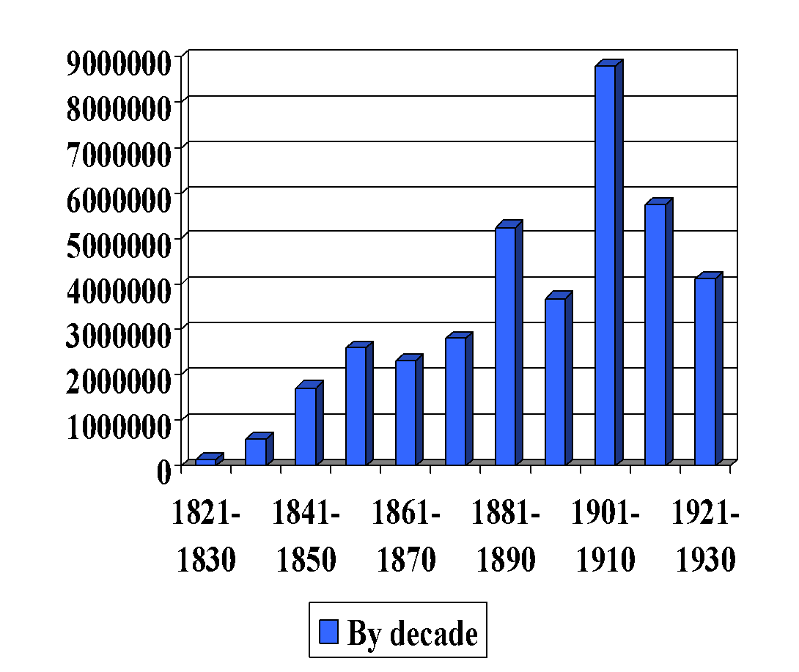
- First Europeans established settlements in the early 17th century
- Africans began being forced onto ships around 1619
Era of Immigration
- Immigration means moving into one country from another
- “Great Era of Immigration” lasted roughly from 1820–1930
German Immigration
- Earliest German immigrants settled in Pennsylvania
- Large numbers came in the 1850s
- Settled in present-day Midwestern states
- Left Germany for economic and political reasons
Scandinavian Immigration
- Arrived in large numbers beginning in the mid-1800s
- Drawn by abundance of farmland on the frontier
- Finnish immigrants faced greater language barriers
- Scandinavians flocked to urban areas in the late 19th century
Irish Immigration
- Early Irish immigrants were Presbyterians from Ulster (Scots-Irish)
- Most Irish immigrants were Catholic
- Fled British because of religious persecution
- Irish immigration increased dramatically in the 1840s -- Potato famine
The Irish in America
- Industrial Revolution in the United States attracted Irish immigrants
- Most Irish moved to the urban cities of the Northeast
- Most worked jobs in factories or coal mines, or as servants or maids
Prejudice against the Irish
- Disdained or disliked for their Catholicism and large families
- Stereotyped as alcoholics who got into a lot of fights. A stereotype is an oversimplified standardized image of a person or group.
- Resentment or bitterness against the Irish built over competition for jobs
Nativism
- Favoritism to native-born Americans, meaning those “born in America”
- This gave rise to anti-immigrant groups and immigration restrictions
Anti-Irish Nativism and the Know Nothing Party
- The anti-immigrant American Republican Party began in 1843 a.k.a. the Know Nothing Party
- The party was secretive, therefore, when a member of the party was asked what they believed in they would state “I know nothing”, hence the nickname of the party.
- “Know Nothing” movement– advocated for immigration limits
- Dissolved in the years before the Civil War (1861-1865) due to a divide over slavery
The Gold Rush
- Immigrants followed the Gold Rush after 1848
- Hoped to strike it rich in gold or to work in new businesses that arose along with the Gold Rush
- Nativist sentiment increased amongst non-immigrant miners
- The Chinese were particularly resented
Chinese Railroad Workers
- Many Chinese worked on the transcontinental railroad
- They received lower pay than their white counterparts
- Extremely dangerous working conditions
Anti-Chinese Sentiment
- Because of white resentment and prejudice Chinese were not allowed to vote or hold elected office
- U.S. economy declined after the Civil War and the Chinese were blamed for job competition and depressed wages
- Workingman’s Party tried to put an end to Chinese immigration
Chinese Exclusion Act – 1882
- The Chinese Exclusion act was the first major law in U.S. history to restrict immigration.
- The act prohibited Chinese laborers and miners from entering the country for the next 10 years.
- It also specified that Chinese immigrants already in the United States could not become citizens
Negative Portrayals of Immigrants in Political Cartoons
- Political cartoons popular in the mid-19th century had racist portrayals of immigrants
- Even in cartoons that were pro-immigration, negative stereotypes persisted
The Journey
- Most immigrants traveled in steerage class (third class)
- Terrible conditions on board the ship & often diseases would spread
- Two-week journey
Ellis Island
- Most immigrants after 1892 were processed at Ellis Island, an immigration station where new immigrants were examined.
Ellis Island: Medical & Legal Examinations
- Everyone was checked for contagious diseases and physical impairments, reading and writing ability, financial status
- Most people screened at Ellis Island were eventually admitted into the United States
Immigrant Work
- Variety of jobs, typically manual labor or factory work
- Low wages
- Child labor among immigrants was common
The “Melting Pot”
- Cultures lose their unique qualities while blending together-- Assimilation
- A popular idea among 19th-century intellectuals was “Americanization”– a program designed to help immigrants assimilate or become more American
The “Salad Bowl”
- Cultures retain their unique identities while mixing together
- Two terms to define the “salad bowl” are cultural pluralism and multiculturalism
- Most historians feel this is a more accurate picture of what happened, but some would argue the opposite

