1.3
WESTWARD EXPANSION LECTURE HANDOUT
Key Terms:
Manifest Destiny
Homestead Act
Reservations
Assimilation
Dawes Act
Wounded Knee
Ghost Dance
Essential Question:
What was the effect of westward expansion on Native Americans?
Americans Move West
Manifest Destiny
the attitude prevalent during the 19th century period of American expansion that the United States not only could, but was destined to, stretch from coast to coast. It was a popular belief that God wanted Americans to move west.
Homestead Act (1862)
A bill passed to encourage settlers to move west
- 160 acres of land was given to any settler who was an American citizen, or who had applied for citizenship
- Had to be committed to farming the land for six months of the year, and pay the $10 registration fee for the land.
Frontier Settlements: 1870-1890
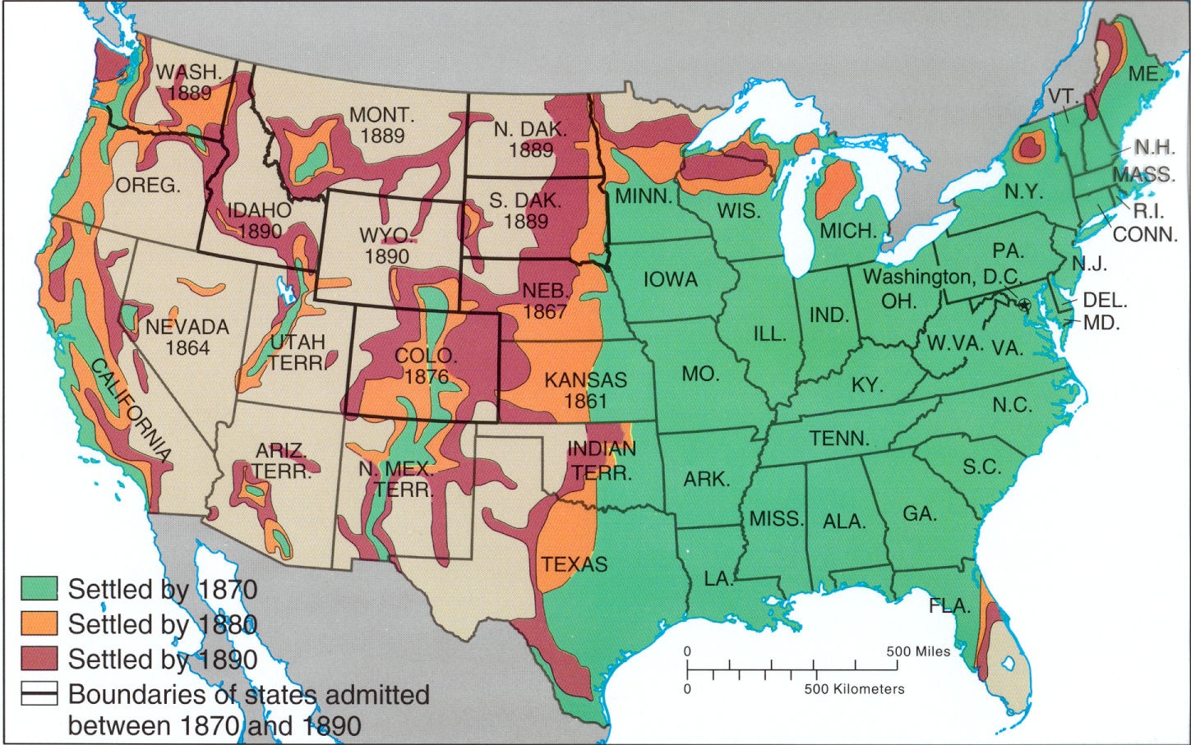
Indian Reservations
- An American Indian reservation is an area of land managed by a Native American tribe under the United States Department of the Interior's Bureau of Indian Affairs (an agency of the U.S. government).
- Native Americans are forced to live on reservations by the U.S. Government.
Indian Appropriations Act (1851)
- Allocated money to move western tribes onto reservations.
- According to the federal government at that time, reservations were to be created in order to “protect” the Native Americans from the growing intrusion of whites moving westward.
Dawes Act (1887)
- Reservations were broken up into "allotments" that were given out to individual families
- Those who accepted allotments and lived separately from the tribe would be granted United States citizenship.
- Goal of the Dawes Act: to get Native Americans to live like white Americans
Assimilation of Native Americans
- Assimilation is process by which a person or a group's language and/or culture come to resemble those of another group.
- The Carlisle Indian School was founded in 1879 by Captain Richard Henry Pratt under the authority of the U.S. Government
- This was a boarding school to immerse Native Americans into Euro-American culture and teach them skills to advance them in society.
- Used as the model for 26 other “assimilation” schools in 15 different states
- Closed in 1918
Prominent Native American Figures
Chief Seattle’s speech 1854
“How can you buy or sell the sky, the warmth of the land? The idea is strange to us.
If we do not own the freshness of the air and the sparkle of the water, how can you buy them? Every part of this earth is sacred to my people. Every shining pine needle, every sandy shore, every mist in the dark woods, every clearing and humming insect is holy in the memory and experience of my people. The sap which courses through the trees carries the memories of the red man. The white man's dead forget the country of their birth when they go to walk among the stars…. So, we will consider your offer to buy our land. But it will not be easy. For this land is sacred to us..”
Chief Joseph’s surrender: Fight No More Speech
- Chief of the Nez Perce Tribe of Wallowa Valley, Oregon
- “I am tired of fighting. Our chiefs are dead… Hear me, my chiefs. I am tired. My heart is sick and sad. From where the sun now stands, I will fight no more forever.”
Military Conflict with Native Americans
The Battle of Little Big Horn (1876)
- commonly referred to as Custer's Last Stand
- between the combined forces of the Lakota, Northern Cheyenne, and Arapaho tribes against the 7th Calvary Regiment of the U.S. Army
- Native American Leaders: Sitting Bull, Crazy Horse, Chief Gall
- 7th Calvary Lead by George Armstrong Custer
- Last major victory for the Native tribes
- Gen. Custer and 200 of his men all died
Massacre at Wounded Knee (1890)
- Battle that was the last large-scale attempt by Native Americans to resist American settlement in the Great Plains region. Federal soldiers opened fire on Native Americans
- Killed around 300 Native Americans
- 90 men and more than 200 women and children
Ghost Dance Movement (1890)
- The Ghost Dance was a religious movement that was an answer to the conquest of Native Americans by the U.S. government. It was an attempt to revitalize traditional culture and to find a way to face increasing poverty, hunger, and disease, all representing the reservation life of the Native Americans in the late 19th century.
- Some believed Ghost Dance ceremonies and songs would bring back the dead, return plentiful buffalo herds, and induce a natural disaster that would sweep away whites, thus restoring the Indian way of life that had existed prior to European contact.
What were the effects of westward expansion?
- Native Americans forced to live on reservations
- Destruction of the Bison (Buffalo) Herds
- Military conflict between Whites and Native Americans resulted in many deaths.
- Loss of culture

Westward Expansion Debate
Directions:
Please discuss these questions in your group. One person in your group will be the scribe. This person will write down all of the answers for your group. Turn in one sheet of paper when your group is finished.
Direcciones:
Por favor discutir estas preguntas en su grupo. Una persona en su grupo será el escriba. Esta persona va a anotar todas las respuestas para su grupo. Entregue una hoja de papel cuando su grupo ha terminado.

- Was it a good idea for Americans to expand westward?
- Was this expansion within our rights as Americans?
- It is in man’s nature to seek expansion.
- Could this expansion be considered sinful?
- Is there a way to expand that is not harmful?
- Is there a positive way to interpret Western expansion?
- How would America look today if its people had never crossed the Mississippi?

Westward Expansion Debate
Directions:
Please discuss these questions in your group. One person in your group will be the scribe. This person will write down all of the answers for your group. Turn in one sheet of paper when your group is finished.
Direcciones:
Por favor discutir estas preguntas en su grupo. Una persona en su grupo será el escriba. Esta persona va a anotar todas las respuestas para su grupo. Entregue una hoja de papel cuando su grupo ha terminado.

- Was it a good idea for Americans to expand westward?
- Was this expansion within our rights as Americans?
- It is in man’s nature to seek expansion.
- Could this expansion be considered sinful?
- Is there a way to expand that is not harmful?
- Is there a positive way to interpret Western expansion?
- How would America look today if its people had never crossed the Mississippi?

